**Exercise 5: Triggers**

**Scenario 1:** Automatically update the last modified date when a customer's record is updated.

**Script Output:**

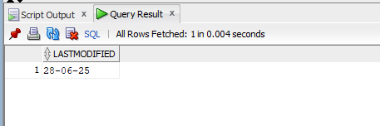

**Table Output:**

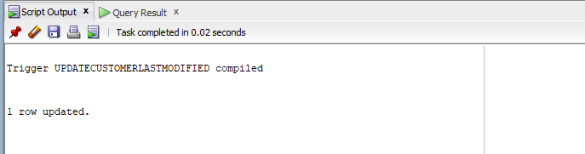

**Scenario 2:** Maintain an audit log for all transactions.

**Table Output:**

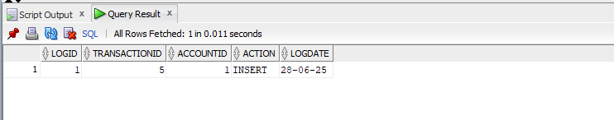

**Script Output:**

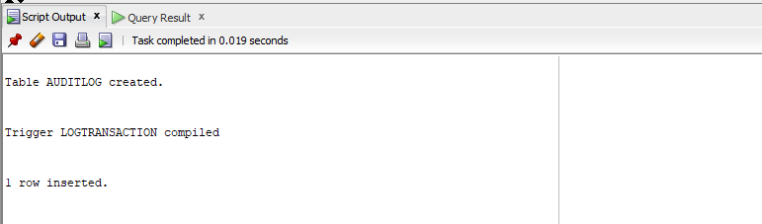

**Scenario 3:** Enforce business rules on deposits and withdrawals.

**Script Output:**

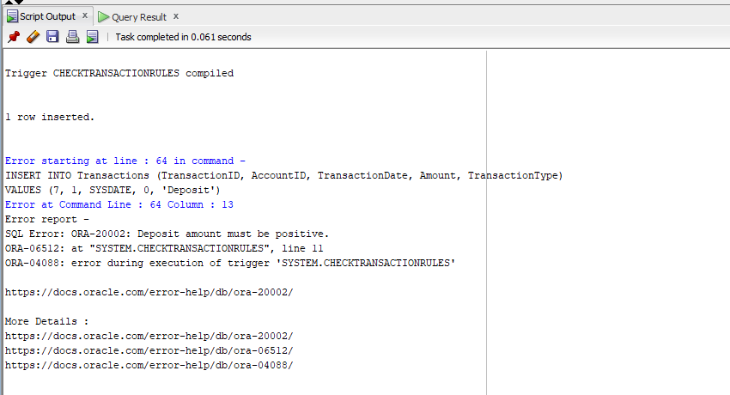

**Table Output:**

